[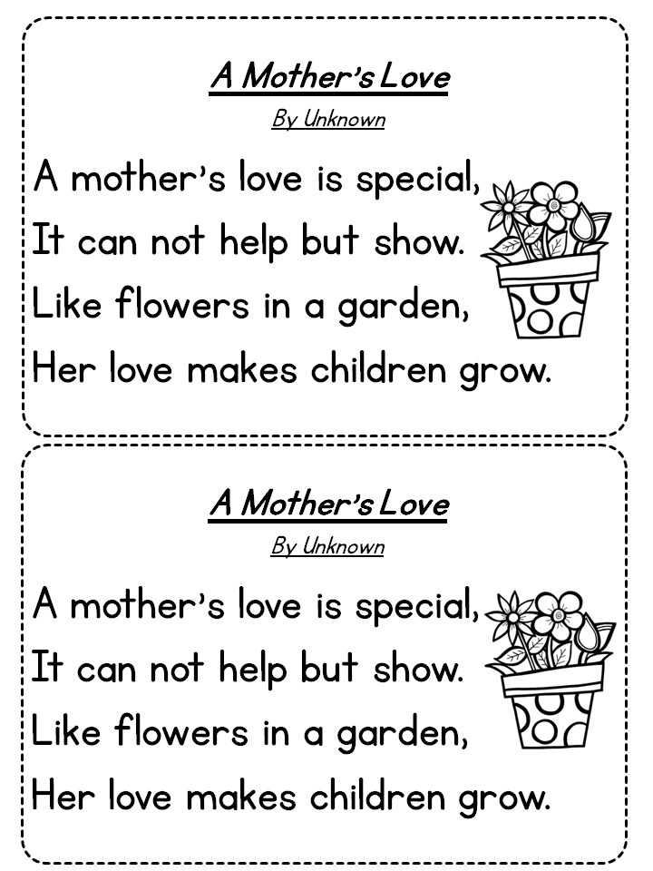](http://www.google.com/url?sa=i&rct=j&q=&esrc=s&source=images&cd=&cad=rja&uact=8&ved=0ahUKEwjgnM3Zjb3TAhUI4yYKHdUeAF8QjRwIBw&url=http%3A%2F%2Ftamaravrussell.com%2F2014%2F04%2Fmay-poetry-journal%2F&psig=AFQjCNFBEt5ilBicbZHPROE60z2gyUd2_A&ust=1493123526875808)