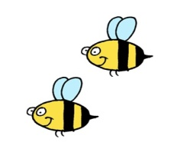
Days of Spring

The days of spring are here
Warm sunny days are near
Birds in trees, flowers and bees
The days of spring are here.

